
2021 Cross Country Event Information Pack

Conveners: Maddi Cua & Steve McKerrow
Venue: Lord Nelson Park, St Arnaud
Date: Tuesday 13th July, 2021

*This is a combined Secondary & Primary Event*
RACE BIB COLLECTION
- Athletes will be required to collect a race bib at the RACE VENUE prior to their event.
- The distribution of Race Bibs will be done in the order that the events are conducted on the day
- Students should collect their Race Bib up to 45mins prior to the start time of the race they are competing in. These will be available from the SSV MARQUEE.
- The Race Bib will need to be pinned to the FRONT of the athlete’s shirt. The Race Bibs have a chip in them that will record the athletes time as they cross over the finish line.
- At the conclusion of the race, Bibs will need to be removed and left in the tubs at the finish line. It is very important that students return their Race Bibs at the finish line, Schools will be invoiced $5 (per bib) for any that are not returned.
AGE GROUPS & MULTI CLASS
- Students should be aware of the age group they are competing in; 9/10 years, 11 years, or 12/13 years (NB: There is a 12/13 Years Primary and 12/13 Years Secondary event). Students’ age groups are determined by their age as of 31st December 2021
- Multi Class athletes - 9/10 years, 11 years and 12/13 year old Multi Class will be included in events #15 & #16; Secondary Multi Class Students 12-15years will compete in events #9 & 10; 16-20 years Multi Class will be included in events #5 & 6. Multi Class Students are advised to bring with them on the day evidence of their Multi Class Classification.
MARSHALLING
- Athletes need to listen for PA Announcements calling for them to make their way to the start line. If an athlete is unsure as to whether their event has been announced they can make their way to the start line no sooner than 10mins prior to the advertised start time for their event. The Starters Marshal will supervise athletes at the start line until the Starter begins each race.
WARM UPS & RULES
- No warming up is permitted on the course proper. Walking the course is permitted. Athletes being paced are subject to disqualification.
- Reminder re wearing of Spikes - For ‘12/13 years SECONDARY’, ‘12/13 years PRIMARY and Under’ students are NOT permitted to wear spiked footwear or footwear with blades or cleats constructed of hard plastic. For 14 years SECONDARY and older students’ spikes may be worn but they must be pyramid spikes no longer that 12mm.
FINISHING PROCEDURE
- As students cross the finishing line their time is automatically recorded by the Tomato Timing Results software. Placegetters will be announced on the day with medals being presented to 1st, 2nd, and 3rd placegetters. Secondary Teams a maximum of 4 medals will be presented to the 1st 2nd and 3rd placed teams.
PROTESTS
- Protests will be heard on the day of competition ONLY. Protests received after the day of competition will not be accepted. Protests need to be made immediately an incident occurs or within 10minutes of the conclusion of the event. Appeals can only be made by the school or a school representative - Protest Form, Appeals & Grievances Policy
- Results will be made available following each event and can be accessed using the QR code or via the SSV website following the day of the event.
COURSE OUTLINE
- The course will be marked with flags and cones. Officials will be located at various points around the course. The course is subject to alteration at any time. Should a student require assistance or first aid they should seek the attention of one of the course marshals wearing a yellow Fluro vest with a 2 way radio. If students leave the course or decide not to finish they must immediately report to the Finish Line so we can account for all athletes on the day.
- A map of the course is included in this event information pack.
Images/Video
- During the Championship photographs and video (film) images may be taken of competitors at the SSV event and published on the SSV web page and across social media to celebrate their achievements. If you have any further enquiries please refer to the SSV Photography Filming and Social Media Policy and guidelines to competition via the SSV website.

Schedule of Events (updated 28/05/21)
Secondary Events
#1 10:10am Boys/Mixed 17-20 5000m
#2 10:20am Boys/Mixed 16 5000m
#3 10:35am Girls 17-20 3000m
#4 10:50am Girls 16 3000m
#5 11:05am Boys/Mixed 15 3000m & Boys Multi Class 16-20 3000m
#6 11:20am Girls 15 3000m & Girls Multi Class 16-20 3000m
#7 11:35am Boys 14/Mixed 3000m
#8 11:50am Girls 14 3000m
#9 12:05pm Boys/Mixed 12/13 Secondary 3000m & Boys Multi Class 12-15 3000m
#10 12:20pm Girls 12/13 Secondary 3000m & Girls Multi Class 12-15 3000m

Primary Events:
#11 12:40pm Boys 12/13 Primary 3000m
#12 12:55pm Girls 12/13 Primary 3000m
#13 1:10pm Boys 11 3000m
#14 1:25pm Girls 11 3000m
#15 1:40pm Boys 9-10 2000m & Boys Multi Class 9/10, 11, 12/13 2000m
#16 1:55pm Girls 9-10 2000m & Girls Multi Class 9/10, 11, 12/13 2000m

Qualifying for SSV State Cross Country Championships:
- Primary & Secondary Individual – The top 12 individual runners in each age group progress to SSV State Championships
- Secondary Team – All Individual runners are automatically entered into the Teams Category. A Team comprises of a min. of 3, max. of 4 runners competing for the same school. The team score is determined by the combined placings of the top 3 runners from the one school. In the event of a tie, the team with the best placed ‘third’ runner shall be declared the winner. If no school has min. of 3 runners in top 12, the next best placed runner outside of the 12 will be considered as part of the Team. The Top 12 individual runners in each Multi Class age group progress to SSV State Cross Country Championships.

- 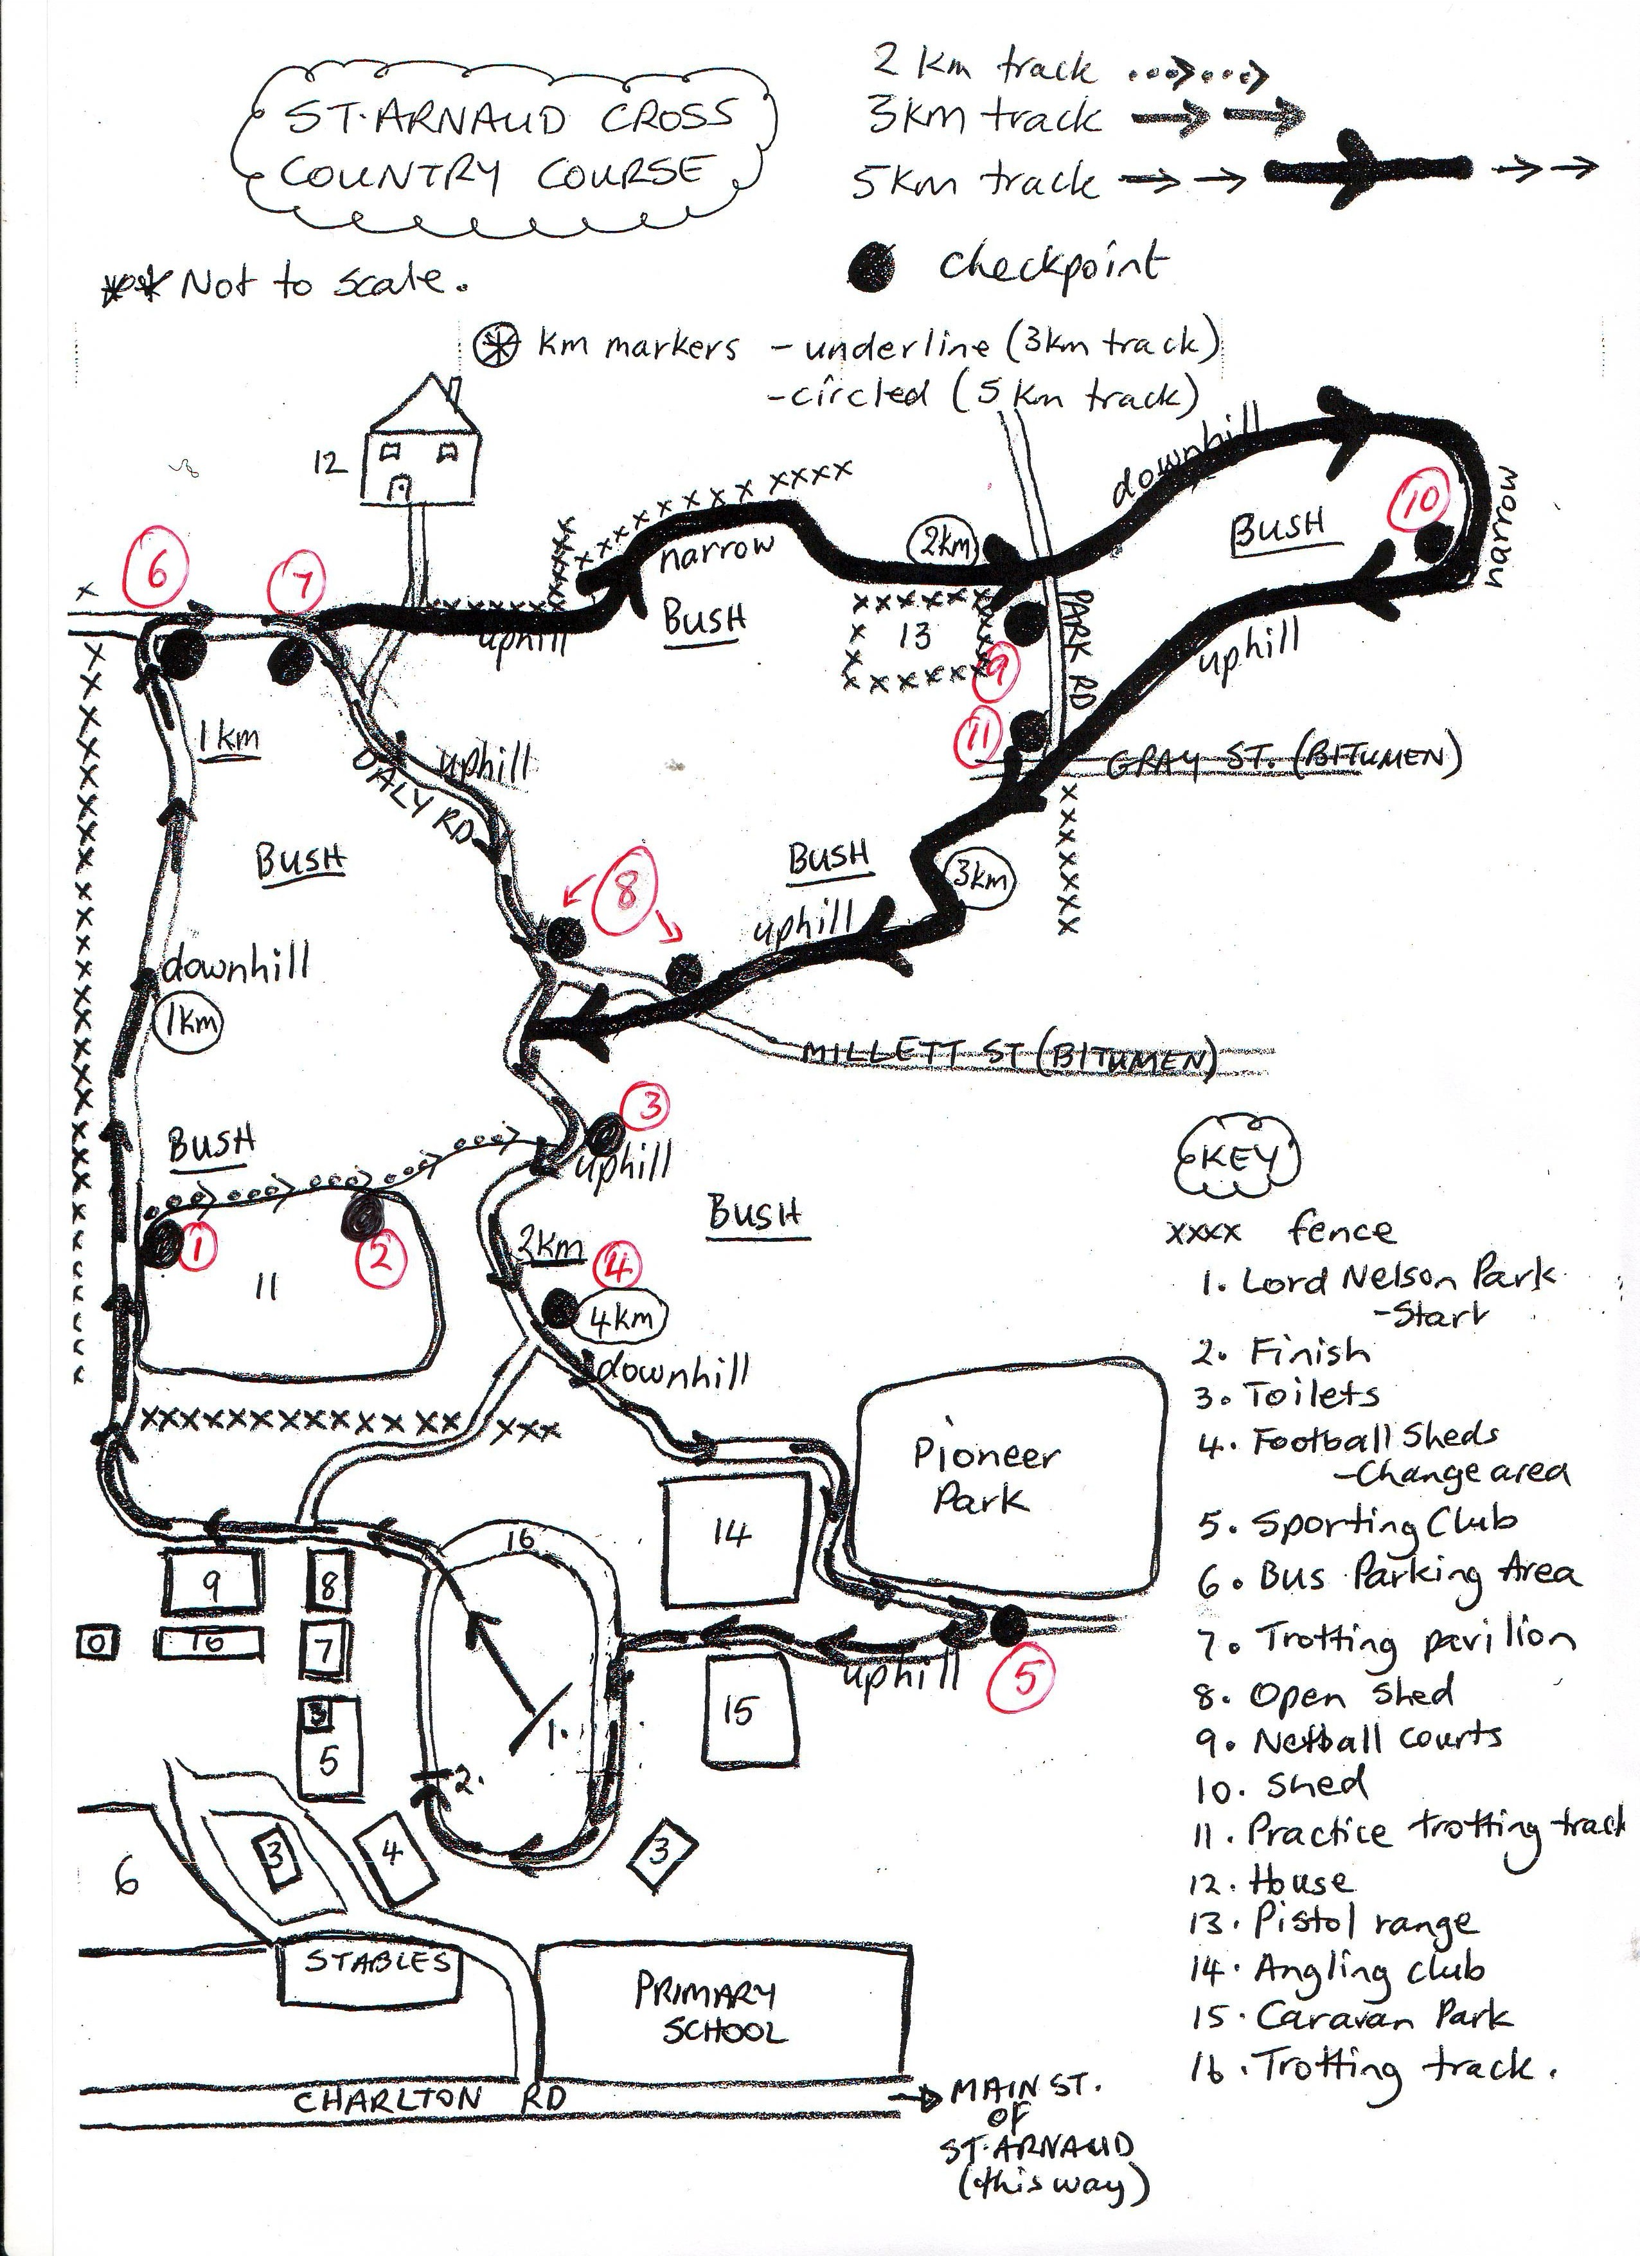



RESULTS

Please Scan the QR code below to obtain Race Results for all
SSV Region Cross Country events for 2021



